**ASSIGNMRNT 4**

|  |  |
| --- | --- |
| Date | 9 November 2022 |
| Name | Banupriya |
| Team ID | PNT2022TMID36774 |

# Question1:

*Write code and connections in wokwi for the ultrasonic sensor.

*Write code and connections in work for ultrasonic sensor.Whenever distance is less than 100cms send"alert"to ibm cloud and display in device recent events.

# Code:

|  |
| --- |
| #define ECHO_PIN 1  #define TRIG_PIN 9    void setup() { **Serial**.begin(115200); pinMode(LED_BUILTIN, OUTPUT); pinMode(TRIG_PIN, OUTPUT); pinMode(ECHO_PIN, INPUT);  } float readDistanceCM() { digitalWrite(TRIG_PIN, LOW); delayMicroseconds(2); digitalWrite(TRIG_PIN, HIGH); delayMicroseconds(10); digitalWrite(TRIG_PIN, LOW); int duration = pulseIn(ECHO_PIN, HIGH); return duration * 5.044/2;  } void loop() {  float distance = readDistanceCM(); bool isNearby = distance < 100; digitalWrite(LED_BUILTIN, isNearby); **Serial**.print("Measured distance: "); **Serial**.println(readDistanceCM()); delay(100);  } |

WOKWI LINK : https://wokwi.com/projects/347820446775771732

# Solution :

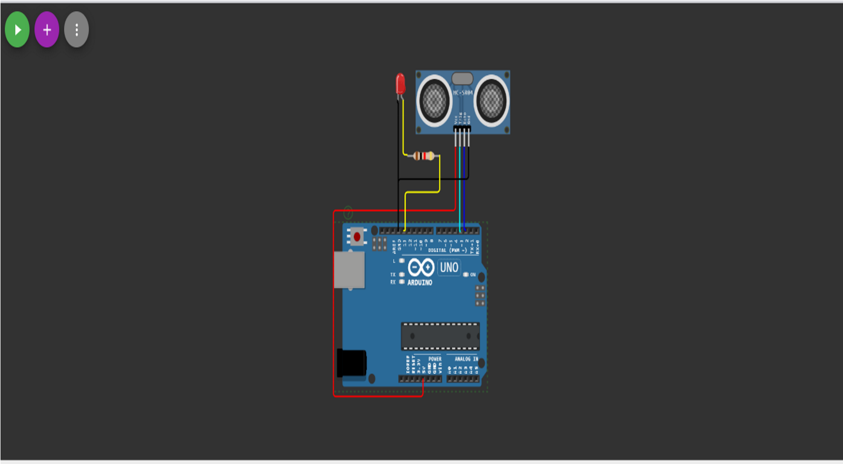

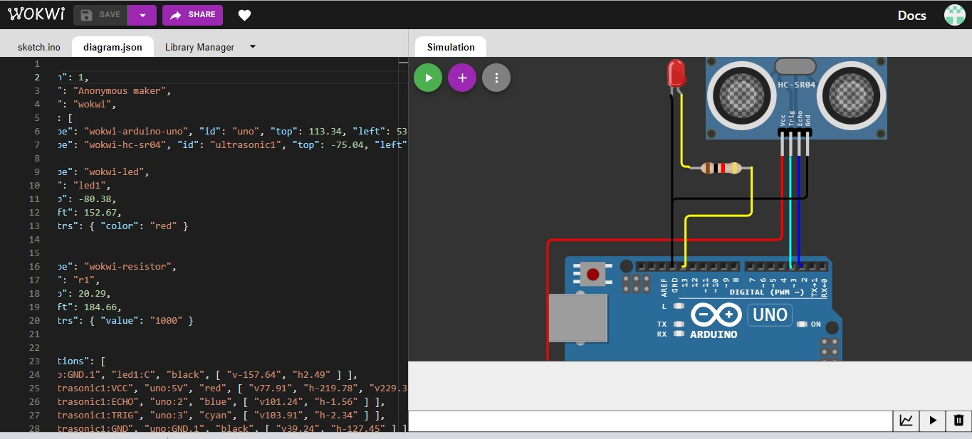

# Solution run:

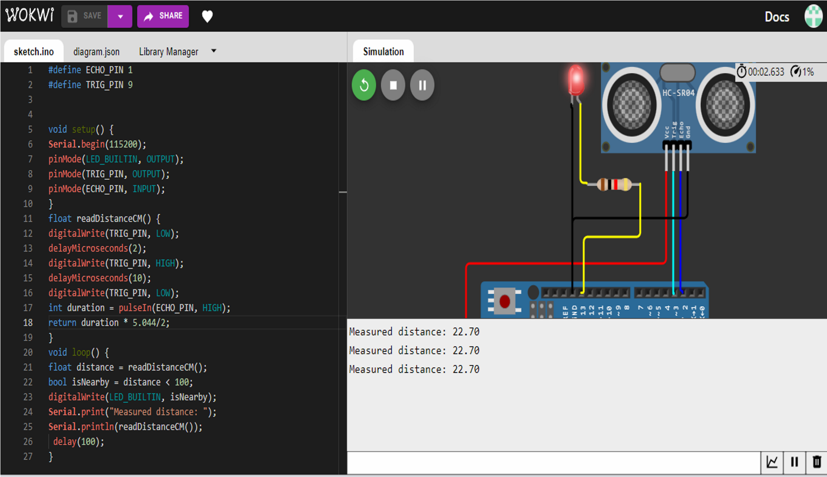

OUTPUT:

DATA IS SENT TO IBM CLOUD WHEN NO OBJECT IS DETECTED

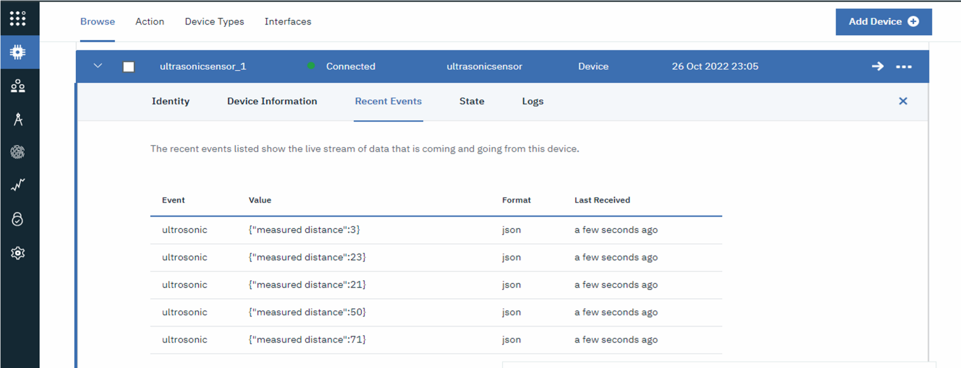

When no object is detected :

